

TRIBHUVAN UNIVERSITY INSTITUTE OF ENGINEERING
NATIONAL COLLEGE OF ENGINEERING

A
MAJOR PROJECT REPORT ON

“AUTOMATIC ROUTINE GENERATOR USING BACKTRACKING ALGORITHM”

SUBMITTED BY:
BIBEK ARYAL (NCE077BCT008) MIJASH ACHARYA (NCE077BCT016) PRERANA SUBEDI (NCE077BCT022) SUSMITA DHAMALA (NCE077BCT037)

SUBMITTED TO:
DEPARTMENT OF ELECTRONICS & COMPUTER ENGINEERING

LALITPUR, NEPAL MARCH, 2024

Page of Approval

TRIBHUVAN UNIVERSITY
INSTITUTE OF ENGINEERING
PULCHOWK CAMPUS
DEPARTMENT OF ELECTRONICS AND COMPUTER ENGINEERING
The undersigned certify that they have read, and recommended to the Institute of Engineering for acceptance, a project report entitled ”Travel Advisor Kathmandu” submitted by Bibek Aryal, Mijash Acharya, Prerana Subedi and Susmita Dhamala in partial fulfilment of the requirements for the Bachelor’s degree in Electronics Communication / Computer Engineering.

_________________________________________________
Er.Anup Shrestha
Supervisor
Department of Computer Engineering

__________________________________________________
Er.Suroj Burlakoti
HOD
Department of Electronics and Computer Engineering

__________________________________________________
Name
External Examiner
Name of the coordinating committee

DATE OF APPROVAL: March.2025

Copyright

The author has agreed that the Library, Department of Electronics and Computer Engineering, National College of Engineering, and Institute of Engineering, may make this report freely available for inspection. Moreover, the author has agreed that permission for extensive copying of this project report for scholarly purpose may be granted by the supervisors who supervised the project work recorded herein or, in their absence, by the Head of the Department wherein the project report was done. It is understood that the recognition will be given to the author of this report and to the Department of Electronics and Computer Engineering, National College of Engineering, Institute of Engineering in any use of the material of this project report. Copying or publication or the other use of this report for financial gain without approval of to the Department of Electronics and Computer Engineering, National College of Engineering, Institute of Engineering and author’s written permission is prohibited.
Request for permission to copy or to make any other use of the material in this report in whole or in part should be addressed to:
Head
Department of Electronics and Computer Engineering
National College of Engineering
Talchhikhel, Lalitpur
Nepal

Acknowledgements
We would like to express our sincerest gratitude and appreciation to all those who have contributed to the completion of this project. First and foremost, we extend our heart- felt thanks to Er.Anup Shrestha, our supervisor, for his invaluable guidance, support, and encouragement throughout the duration of this project. His expertise and insight- ful feedback have been instrumental in shaping the direction and quality of this work. Furthermore, we would also like to express our heartfelt gratitude towards all our department teachers for their constant guidance and input on the project. We are also thankful to the Department of Electronics and Computer Engineering, for providing us the necessary resources and guidance materials for the successful completion of this project. This project would not have been possible without the contributions and sup- port of all those mentioned above. Thank you.

Abstract
Developing an automatic routine generator using back tracking algorithm is a web- based project designed for timetable creation for the National College of Engineer- ing(NCE). The primary aim is to develop a system that automates the generation of a college timetable, considering the availability and workload of teachers, the distribution of subjects across different semesters, and the constraints specific to practical sessions. Leveraging Constraint Satisfaction Problem (CSP) techniques, the system integrates multiple constraints such as teacher availability, workload limits, qualified teacher assignment, no teacher overlap, and subject daily limits. The project uses a MongoDB database to store detailed information about subjects and teachers, categorized by department and semester. The timetable generation process starts with user inputs for the department, semester, college start and end times, and period length, and then fetches relevant data from the database to apply the CSP model and generate the initial timetable. Additionally, the system employs algorithms to prioritize part-time teachers, balance workloads, and schedule practical sessions effectively. We will also implement mechanisms to dynamically accommodate changes and updates to the generated timetable based on specific inputs from teachers for each alteration. By automating the timetable generation process, the project aims to reduce administrative overhead, ensure fair workload distribution among teachers, demonstrating flexibility in handling various constraints and adapting to departmental needs.

Keywords: web-based, ML, contraints, CSP, automatic, Mongodb

Contents

Page of Approval i
- Copyright ii
- Acknowledgements iii
- Abstract iv
List of Figures vii
List of Tables viii
List of Abbreviations ix
- Introduction 1
  - Background 1
  - Problem statements 2
  - Aims and Objectives 3
  - Scope 3
- Literature Review 4
  - Related work 4
  - Related theory 6
- Proposed Methodology 7
  - System Block Diagram 7
  - Algorithms 8
    - Schedule Generation using Constraint Satisfaction Problem (CSP) and Backtracking Algorithm 8
  - Proposed System Design 9
    - Admin Functionalities 9
  - System Development Model 10

8 Tools Used |  | 12
8.1 Frontend Development |  | . . . . . . . . . . . . . . . . . . . . . . . . . . | 12
8.2 Backend Development |  | . . . . . . . . . . . . . . . . . . . . . . . . . . | 13
9 | Result and Discussion |  | 14
 | 9.1 Data Collection . . . . . . . . . . . . . . . . . . . . . . . . . . . . . . |  | 14
 | 9.2 Data Preprocessing . . . . . . . . . . . . . . . . . . . . . . . . . . . . |  | 16
 | 9.3 Output . . . . . . . . . . . . . . . . . . . . . . . . . . . . . . . . . . . |  | 16
 | 9.4 Outcome . . . . . . . . . . . . . . . . . . . . . . . . . . . . . . . . . . |  | 26

10 Future Enhancements 27
References 27

List of Figures
  - System Block diagram 7
  - Proposed Diagram of System 10
  - Subject-Wise Workload Format 15
  - Teacher-Wise Workload Format 15
  - Teacher Data 16
  - Subject Data 16
  - Home Page 17
  - Login Page 17
  - Admin Dashboard 18
  - User Management Page 18
  - Teacher Management Page 19
  - Subject Management Page 19
  - Teacher Edit Page 20
  - Sign up Page 20
  - System Training Data Flow Graph………………………………………………..20

List of Tables
  - Workload distribution by designation 22
  - Room availability for different practical types 23

List of Abbreviations
AI Artificial Intelligence
CRUD Create Read Update Delete CSP Constraint Satisfaction Problem CSS Cascading Style Sheet
HOD Head Of Department
HTML HyperText Markup Language
ML Machine Learning
MVT Model View Template
RDBMS Relational Database Management System
SQL Structured Query Language

Introduction
The Automated Routine Generator represents a transformative difference in the man- agement of scheduling processes within educational institutions, specifically universi- ties. This system uses advanced algorithms and technologies to automate the tough task of generating class schedules, thereby advanced resource allocation, minimizing con- flicts, and significantly reducing errors. By replacing labor-intensive manual scheduling methods with an efficient and precise automated approach, the Automated Routine Gen- erator promises to redefine the academic landscape. Its intuitive interface and strong backend architecture offer a better user experience, ensuring optimal scheduling out- comes for students, faculty, and staff alike. With its potential to reduce administrative burdens, and enhance scheduling accuracy, the Automated Routine Generator emerges as a important tool in modernizing educational institutions and fostering a conductive learning environment.

Background
Before the concept of automatic routine generators was invented, people relied on man- ual scheduling methods. This involved using physical tools such as calendars, plan- ners, and wall charts, along with basic arithmetic and logical reasoning to allocate tasks and resources. Schedulers, often university administrators or staff, manually assessed constraints like room availability, faculty schedules, and course requirements to create timetables. This process was labor-intensive, time-consuming, and inclined to human error, especially for complex scheduling needs such as university timetables or large- scale industrial operations.
Manual scheduling methods before the emergence of automatic routine generators were time-consuming, susceptible to human error, and inefficient, often resulting in sub op- timal use of resources. These methods struggled with scalability, flexibility, and man- aging complex constraints, leading to inconsistent quality and difficulty in adapting to last-minute changes. Additionally, poor data management and lack of optimization

made decision-making slower and less effective, requiring significant human resources and increasing operational costs. Research on manual scheduling approaches highlights several key limitations: significant time investment, high error rates, and inefficiencies, particularly in complex environments like universities. Manual methods struggle with scalability, adapting to changes, and managing complex constraints, resulting in in- consistent quality and increased operational costs. Comparative studies consistently demonstrate the superiority of automated systems.

Problem statements
Manual routine generation for academic institutions often faces numerous challenges, which can lead to inefficiencies, errors, and overall dissatisfaction among faculty and students. Some of which are:
- The task of routine making can be tedious, time consuming and error prone when done manually. Slightest mistake can lead to a huge disruption in the educational process.
- Routine once made is difficult to alter.

- It can result in inconsistent time allocation which causes imbalanced workloads, inefficient resource use, and administrative challenges.
- Lack of real-time updates leads to miscommunication and delays in addressing the changes.
- Reduced accountability and tracking make it harder to monitor scheduling issues and resource allocation effectively.
- Lack of optimization results in inefficient scheduling and resource use.

- Maintaining historical records becomes challenging, hindering the ability to track past scheduling decisions and learn from previous experiences.

Aims and Objectives
The main aim of our project is to develop a system that automatically generates class routines using Machine Learning.

Objectives:

- To develop a system that can generate a printable routine file

- To implement improved resource management, including faculty and staff management.

Scope
An automated routine generator using machine learning in the context of Nepalese universities offers a wide scope of applications to address various challenges in academic scheduling. By adapting machine learning algorithms to handle the specific requirements of Nepalese universities, such as cultural events and examination schedules, the generator can produce schedules that meet the diverse needs of stakeholders. Additionally, the generator can enhance resource utilization by analyzing historical data to identify usage patterns and allocate resources more efficiently throughout the semester. It can also adaptive adjust schedules based on dynamic factors like faculty availability and unexpected events, ensuring flexibility and responsiveness. Furthermore, machine learning techniques can help detect and resolve scheduling conflicts while incorporating constraints unique to Nepalese universities, such as religious holidays and local festi- vals. By continuously analyzing feedback from teachers and faculty, the generator can tailor schedules to improve satisfaction and accommodate diverse conditions. Integra- tion with existing university management systems streamlines data exchange and facil- itates informed decision-making by providing administrators with actionable insights and recommendations based on data-driven analysis. Overall, an automated routine generator using machine learning has the potential to change academic scheduling in Nepalese universities, improving efficiency, fairness, and stakeholder satisfaction while addressing the unique challenges of the local context.

Literature Review
The development of automated scheduling systems has been a prime focus of research for decades, driven by the need to improve resource allocation and minimize scheduling conflicts in various domains, including educational institutions. This literature review explores the evolution of scheduling methods, the theoretical foundations of automated scheduling algorithms, and the practical applications of these technologies in university settings.

Related work
- Ying, H. K. Mammi proposed a web application that used a genetic algorithm to find the most suitable schedule, referring to constraints such as subject, lecture hall and stu- dent group. The authors defined two types of constraints, i.e., soft constraints and hard constraints. But only strict restrictions are met. Due to the large number of electives offered by the program, there were conflicts between electives. This happened because the soft limits were not followed. It also takes about 5 minutes 34 seconds on average to build the schedule[1].
- Bagul, Mayuri R and Chaudhari, explored various methods for timetable generation, including local search algorithms and constraint programming techniques. They implemented the project by constructing a dataset from the univer- sity’s course timetables, room capacities, and time slots. Initial feasible solutions were generated using a heuristic algorithm, and then refined using a genetic algorithm. Lim- itations of the research: -The project may face limitations in handling the complexity of real-world timetabling scenarios, necessitating further algorithmic refinement to ef- ficiently manage larger datasets and intricate constraints[2].

Ratul Prosad, Md. Ashikur Rahman Khan, and Ishtiaq Ahammad have designed a class routine and exam hall invigilation system using genetic algorithms and a greedy ap- proach. The system automates schedule management and stores all information in a centralized database. It allows for the distribution of classrooms, adjustment of sched- ules under complex conditions, display of available schedules for exam hall surveil-

lance, and effective classroom utilization[3].

Savdekar, Mansi and Bornare, presented an efficient timing algorithm designed for an automated timetable system. This system could handle various challenges and generated schedules for classes and teachers. It considered each teacher’s availability, resource usage, and specific rules for different classes, semesters, teachers, and grade levels. This allowed both teachers and students to view their schedules after a semester ends, even though they do not participate in the planning process[4].

Maryam Alwashahi discussed the investigation and optimiza- tion of course scheduling at Sohar University using a genetic algorithm. The research focuses on creating course timetables that allocate events (time, subject, and faculty) effectively, using available resources and avoiding conflicts. The paper introduced a suitable methodology and an efficient algorithm for solving scheduling problems. The proposed system met all strict constraints without any clashes between schedules. On average, it took 23 minutes to generate the best schedule for one faculty member[5].

They structured a dataset containing faculty, subjects, rooms, and time intervals to fa- cilitate the generation of accurate timetables. Furthermore, they discussed potential enhancements such as refining the backtracking algorithm to handle larger datasets effi- ciently, integrating machine learning for adaptive optimization, and improving the user interface[6].

Rahman, Ashiqur Md and Giasuddin used two heuristic algorithms to address the NP- hard problems of academic routine generation and exam timetabling for universities that followed an open credit system where students could choose any course after com- pleting prerequisites. The algorithms provided reasonably good solutions but had limi- tations in handling all constraints simultaneously and depended on the input data size. The key contributions lay in tackling the challenges of routine and exam scheduling in an open credit system environment through heuristic techniques[7].

Prof. Jyothi Patil and his team purposed a system to create an efficient and conflict-free automatic timetable generator for colleges. The system was implemented using HTML and CSS for the front-end, and Python and MySQL for the back-end, with a genetic algorithm employed to generate the timetables. Several limitations were noted, including the chal- lenges in handling complex constraints, the resource-intensive nature of the genetic al- gorithm, the need for manual adjustments in the event of last-minute changes, and diffi- culties in generating a diverse initial population[8].

Sohail Qureshi, Nikita Veer, Vaishanavi Ugale, and Priyanka Agrawal designed a project aimed to automate timetable generation using a genetic algorithm for optimization. Python l braries like tkinter and Django were used for the interface and web application. Limita- tions included the need for manual adjustments for absences and the resource-intensive nature of the genetic algorithm[9].
While aSc Timetables,a desktop software, significantly aids in creating conflict-free and equitable schedules, its specific features offer notable advantages. It offers features like:
- Automated Scheduling: Efficient, conflict-free timetables.
- Customization: Flexible scheduling options.
- User-Friendly Interface: Easy adjustments and updates.
- Mobile Access: Schedules available on mobile devices.
One significant limitation of aSc Timetables is its labor-intensive setup process. The software requires users to define over 30 constraints, making it time-consuming and demanding to configure. It is not efficient for the university scheduling.[10]

Related theory

Backtracking Algorithm:
Backtracking is a depth-first search algorithm that incrementally builds candidates for the solution and abandons a candidate/backtracks as soon as it determines that this candidate cannot lead to a valid solution.
Implementation in the System:

- Start with an empty schedule.

- Assign the first class to the first available time slot and room that satisfies all constraints.
- Recursively assign subsequent classes to available time slots and rooms.

- If a constraint is violated, backtrack to the previous step and try the next available option.

Proposed Methodology

System Block Diagram

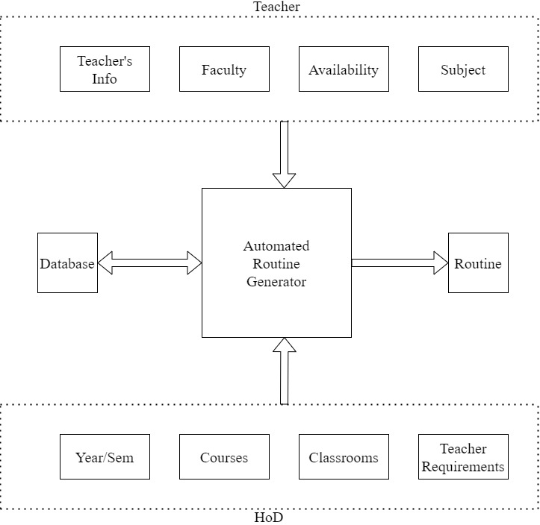

Figure 7.1: System Block diagram
The Automated Routine Generator system consists of four main components: Teacher’s Input, Admin’s/HOD’s Input, Database, and Routine Generation. Teachers input their personal details, faculty, availability, and subjects they will teach, while admins or HODs provide information such as year/semester, courses, classrooms, and teacher re- quirements. All this information is recorded in a central database, which connects to the system. Based on these inputs, the system generates a comprehensive routine that

accommodates all scheduling constraints and preferences. The generated routine can then be viewed or downloaded by the HOD, teachers, and admin.

Algorithms

Schedule Generation using Constraint Satisfaction Problem (CSP) and Backtracking Algorithm

Initialization

        - Start with an empty schedule matrix S where rows represent time slots and columns represent classrooms.
        - Define constraints such as teacher availability T_{i}, room availability R_{j}, and subject requirements C_{k}.

Recursive Function

        - Base Case: If all classes are scheduled, return the schedule S.
        - Recursive Case: For each class c, try assigning it to each time slot t and room r:
          - Check if assigning c to t and r violates any constraints.
          - If no constraints are violated, place c in S[t][r] and recursively call the function with the next class.
        - Backtracking: If a constraints is violated, remove c from S[t][r] (backtrack) and try the next available option.

Mathematical Explanation
This mathematical explanation defines the constraints for scheduling classes by en- suring that a teacher and a room are available for a given time slot. It introduces binary variables: Ti to indicate teacher availability and Rj for room availability. The goal is to assign a schedule S[t][r] such that no teacher or room is double-booked at any time. The example demonstrates the step-by-step assignment of classes to time slots and rooms while adhering to these constraints, ensuring a conflict-free routine.
- Let T_{i} be a binary variable where T_{i} = 1 if teacher i is available at time t.

- Let R_{j} be a binary variable where R_{j} = 1 if room j is available at time t.

- The objective is to find S[t][r] such that:

Σ T_{i} · S[t][r] ≤ 1
n
i=1
and

Σ R_{j} · S[t][r] ≤ 1
m
j=1

for all t and r.

Proposed System Design

System Overview:
The figure 5.2 represents a comprehensive Automated Routine Generator System designed to facilitate the efficient scheduling of academic classes for educational insti- tutions. The system is composed of several key components, which are interconnected to streamline user management, teacher assignments, subject scheduling, and routine generation processes.
User Access and Management The system provides access to two primary roles:

HOD/DHOD (Head of Department/Deputy Head of Department)

- Admin

Users can log in or sign up through a dedicated Login/Signup Module. Once authenti- cated, they are authorized to perform specific tasks based on their assigned roles.

Admin Functionalities
The Admin plays a central role in managing the system’s core data. This includes:

- User Management: Adding, editing, or deleting users who can access the sys- tem.
- Teacher Management: Managing teacher records, including their assigned sub- jects, workloads, and availability.

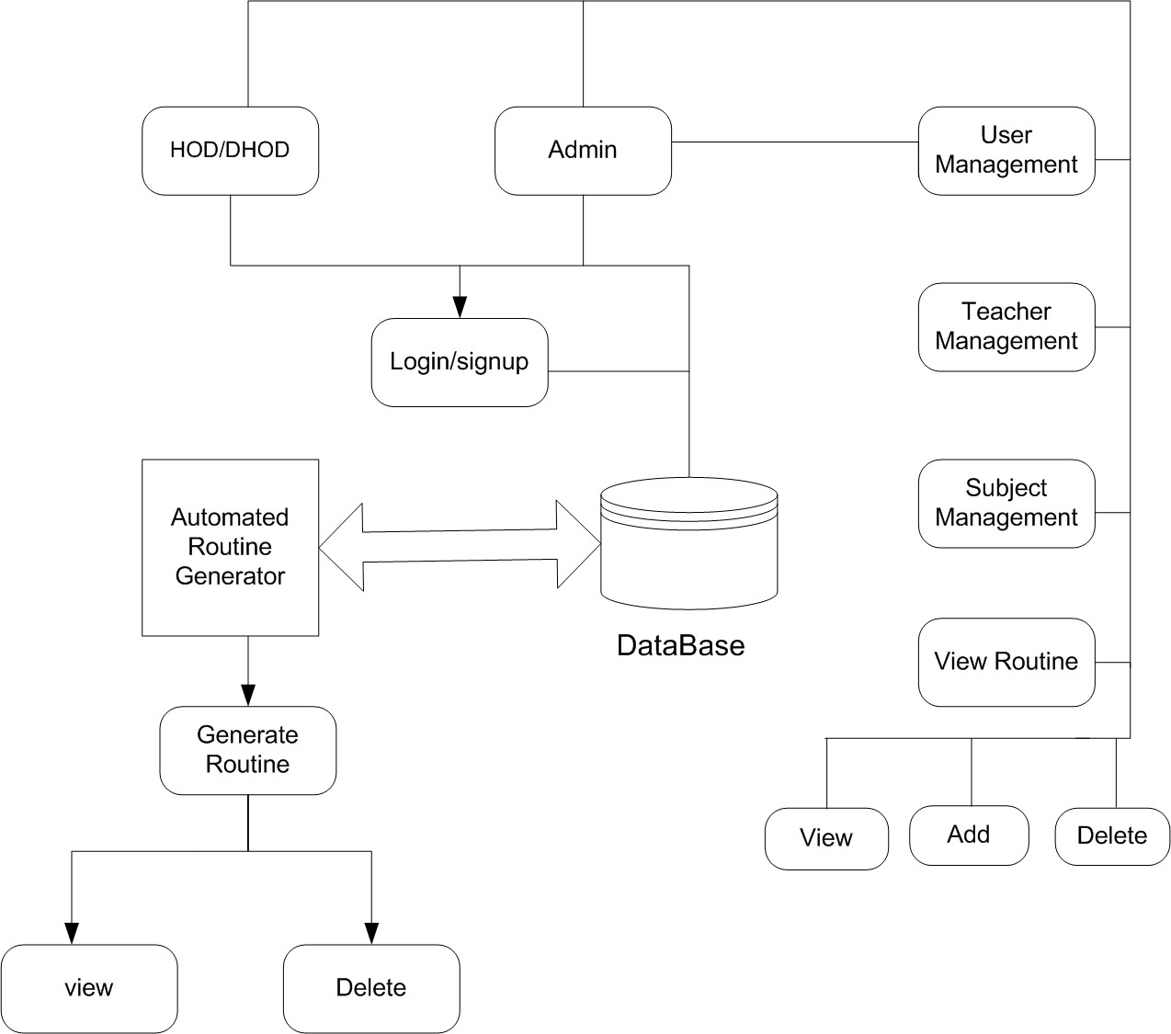

Figure 7.2: Proposed Diagram of System

- Subject Management: Maintaining details about subjects, including their credit hours and practical or theory classifications.

System Development Model
For the development of the ”Automated routine generator using ML” system, we have opted for the Incremental Model as our system development approach. This method breaks down the project into manageable increments, allowing us to deliver functional subsets of the system at regular intervals. By doing so, we can prioritize essential fea- tures, provide early user feedback, and reduce project risks. The model’s flexibility ac- commodates changes and user involvement throughout the development process, ensur- ing a close alignment with user needs. Each increment undergoes thorough testing and deployment, with subsequent iterations incorporating feedback and refining function- alities. This modular development approach enhances maintainability and scalability,

facilitating the integration of new features. The phases include requirements gathering, design, implementation, testing, and enhancement for subsequent increments.

Tools Used

Frontend Development

HTML

Hypertext Markup Language(HTML), serves as the backbone of web pages, defining their structure and content through a series of elements or tags. These elements encom- pass various components like headings, paragraphs, links, images, and forms, collec- tively shaping the visual and functional aspects of a web page. HTML provides the fun- damental framework upon which other web technologies, such as CSS and JavaScript, build to create dynamic and interactive online experiences.

CSS

Cascading Style Sheets, complements HTML by controlling the presentation and layout of web documents. It allows developers to define styles for HTML elements, includ- ing attributes like colors, fonts, spacing, and positioning. By separating content from presentation, CSS enables consistent styling across multiple web pages and ensures a visually appealing and user-friendly interface across different devices and screen sizes.

Bootstrap

It stands as a robust front-end framework, providing developers with a comprehen- sive toolkit for building responsive and mobile-first websites and web applications. By offering pre-designed templates, components, and utilities, Bootstrap streamlines the development process, allowing for rapid prototyping and iteration. Its grid system and responsive design principles ensure that projects are accessible and contributing to a seamless user experience.

Backend Development

Python

Python is a high-level, interpreted programming language known for its readability and simplicity.Python emphasizes code readability with its use of significant indentation. It supports multiple programming paradigms, including procedural, object-oriented, and functional programming. Python’s extensive standard library and vibrant ecosystem of third-party packages make it suitable for a wide range of applications, from web development and data analysis to artificial intelligence and scientific computing. Its simplicity and versatility have contributed to its widespread adoption in both industry and academia.

Mongodb

MongoDB is a NoSQL, document-oriented database designed for scalability, flexibil- ity, and performance. Developed by MongoDB Inc., it stores data in flexible, JSON-like documents, which allows for varied and hierarchical data structures. This schema-less design makes it easier to handle changing data requirements and to scale horizontally. MongoDB supports a rich query language, indexing, and real-time aggregation, en- abling efficient data retrieval and manipulation. Its distributed architecture provides high availability and fault tolerance, making it a popular choice for modern applica- tions that require fast, iterative development and the ability to handle large volumes of data.

Flask

Flask is a lightweight and versatile Python web framework designed for building web applications and RESTful APIs. Known for its simplicity and flexibility, Flask uses WSGI for request handling and Jinja2 for dynamic HTML templating. It includes a built-in development server and debugger, making it ideal for rapid prototyping. Flask’s modularity allows developers to start with a basic app and scale it by adding extensions for features like database integration, authentication, and more. Its ease of learning, active community, and scalability make it suitable for projects ranging from small web- sites to complex APIs and microservices.

Result and Discussion

Overview
We successfully completed the task of collecting and inserting data for courses, teachers, and classes into a MongoDB database. This foundational step ensures that the automatic timetable generation project has the necessary data for accurate and efficient timetable creation. Additionally, we collected data from different faculty heads of NCE to enhance our dataset and ensure thorough coverage of all course offerings and faculty availability.
Additionally, we expanded our dataset by gathering information from different faculty heads at NCE, ensuring that our system considers department-specific constraints, faculty preferences, and course dependencies. This comprehensive approach enhances the accuracy of the generated timetable and ensures that the system includes scheduling logic, conflict resolution mechanisms.

Data Collection

Courses:

- Course Code: Unique identifier for each course.

- Course Title: Descriptive title of the course.

- L: Lecture Hours

- T: Tutorial Hours

- P: practical Hours

- Total: Total credit hours per week.

- Faculty: Faculty responsible for the course.

Teachers:

- Teacher ID: Unique identifier for each teacher.

- Name: Full name of the teacher.

- Department: Department to which the teacher belongs.

- Workload: Total teaching workload assigned.

- Part/Full Time: Employment status.

- Availability: Times when the teacher is available.

- Designation: position held by an individual within an organization, defining their role and responsibilities.
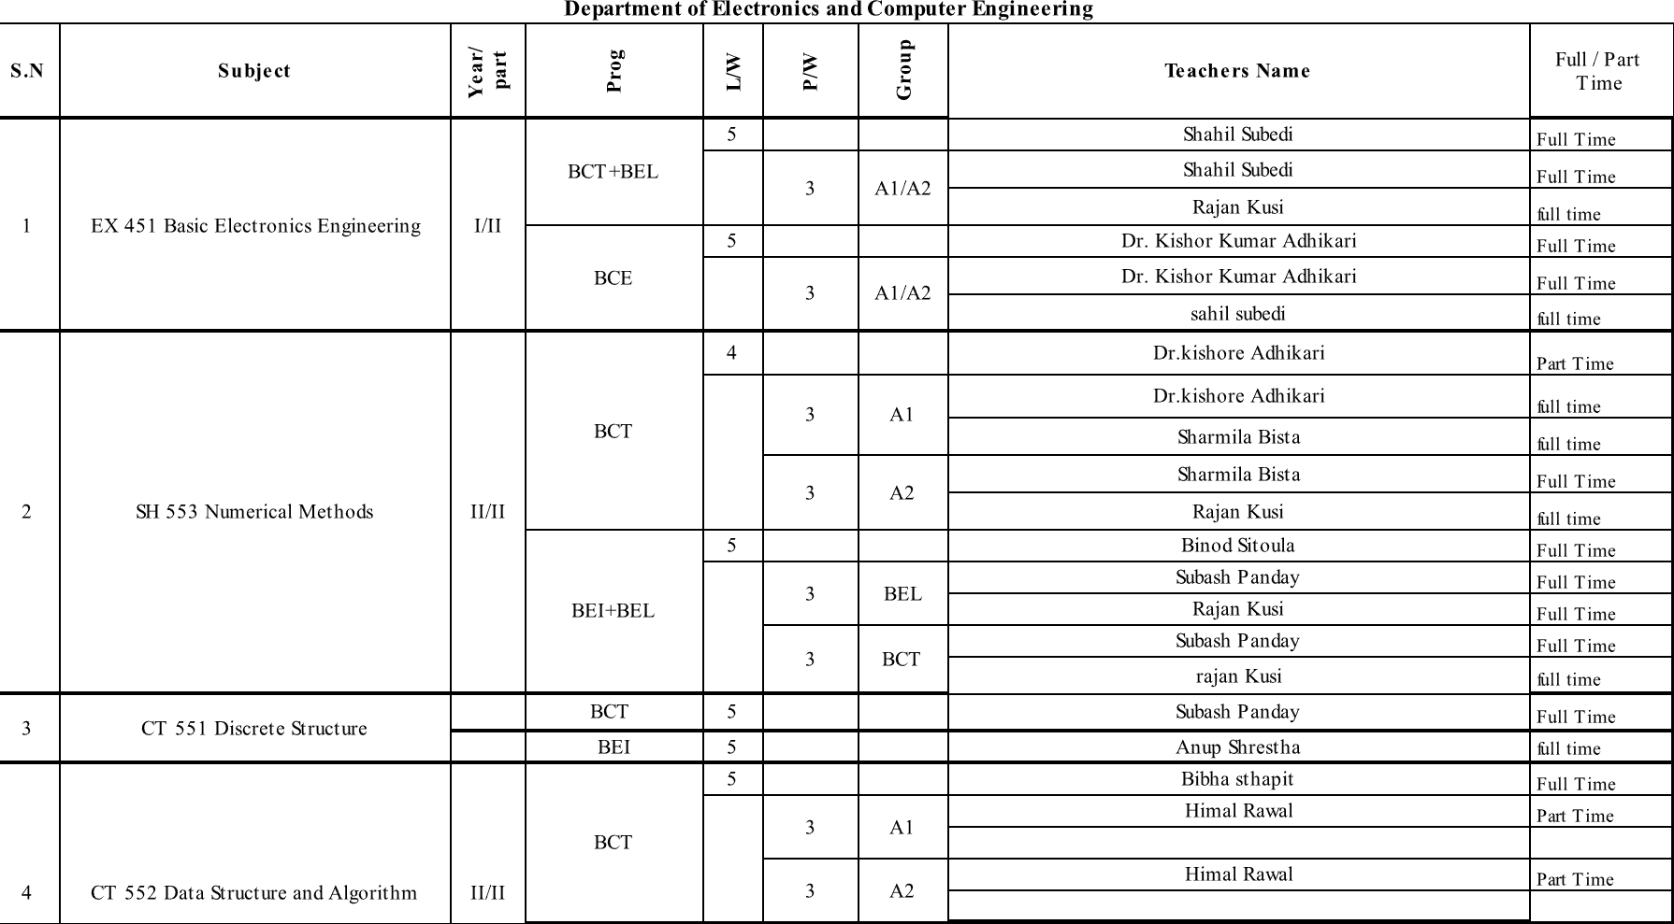

Figure 9.1: Subject-Wise Workload Format

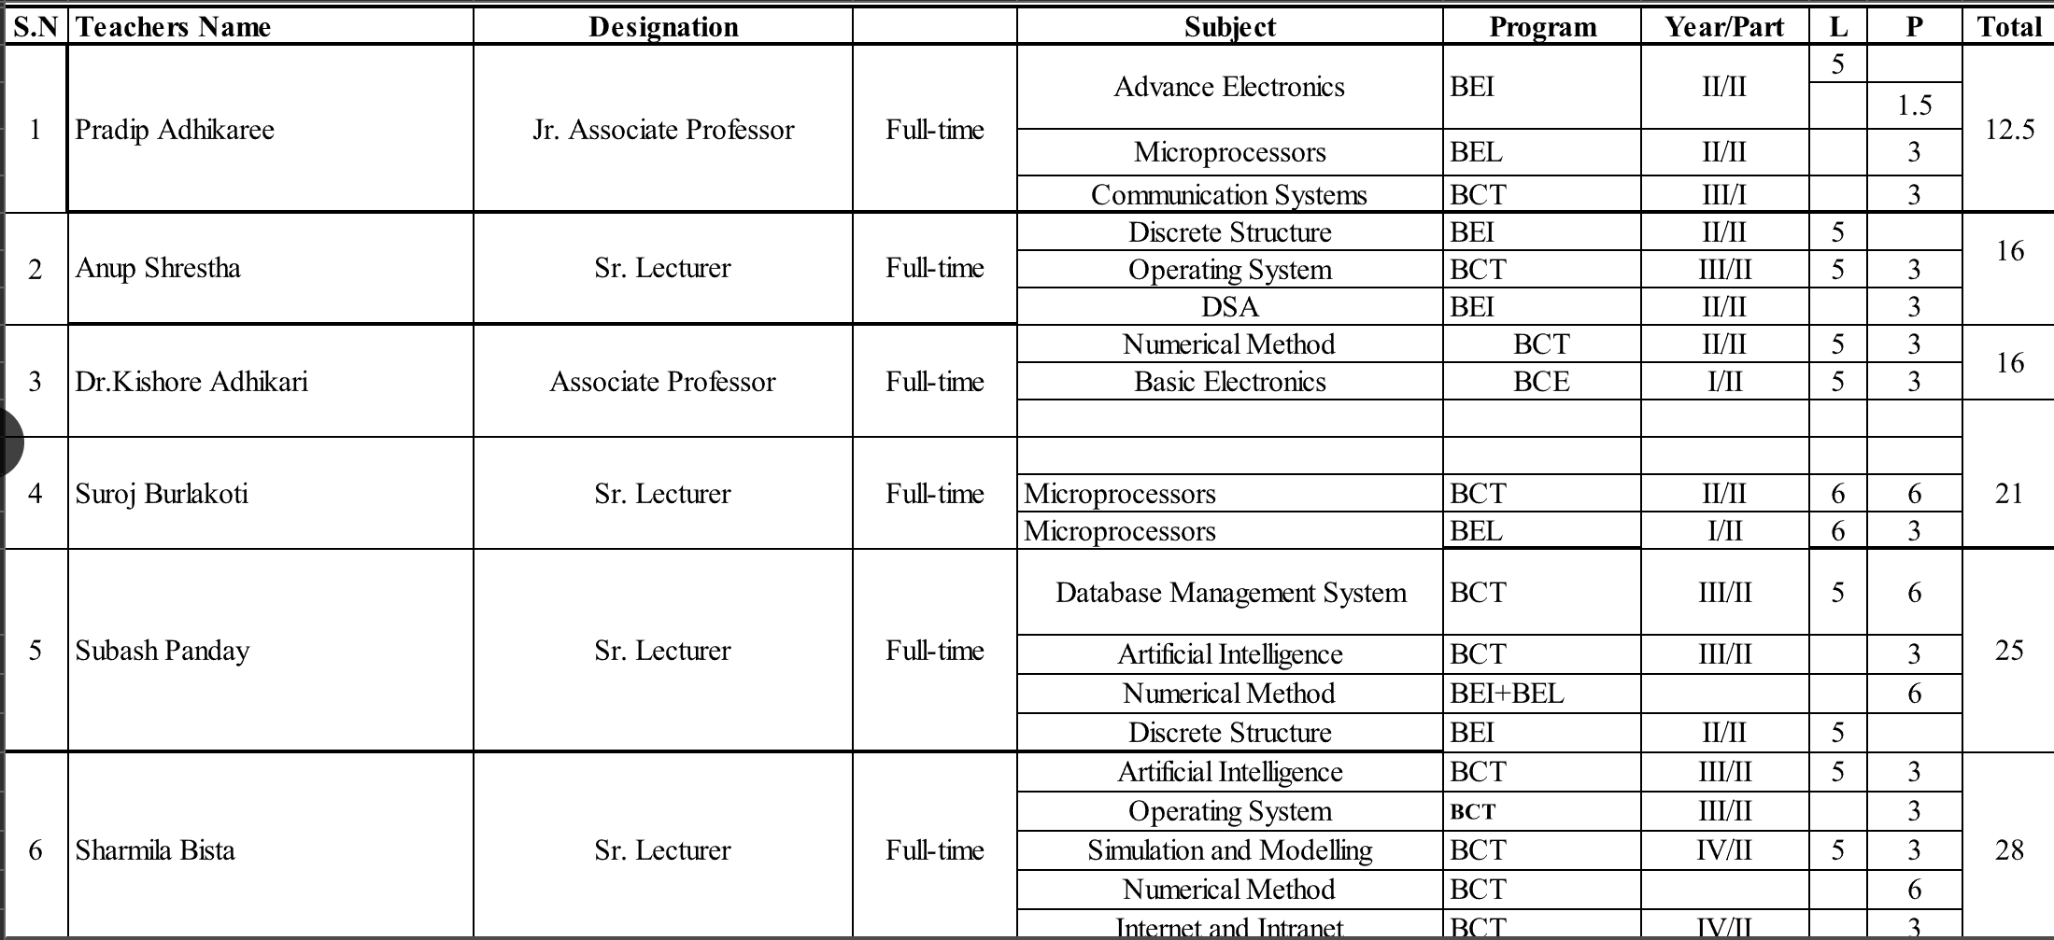

Figure 9.2: Teacher-Wise Workload Format

Data Preprocessing
In preparing our data for the automatic timetable generation project, we began by collecting raw data from various sources, including inputs from faculty heads at NCE. Our initial focus involved rigorous data cleaning to handle missing values, remove duplicates, and rectify inconsistencies. Subsequently, we transformed the cleaned data into JSON format, aligning it with MongoDB’s document-oriented structure for efficient storage and retrieval. This process also included normalization steps to organize data logically and ensure compatibility with our database schema. Additionally, we inte- grated supplementary data from faculty heads to enrich our dataset, ensuring thorough coverage of course offerings and faculty availability. Through systematic validation, we ensured the accuracy and completeness of the converted JSON data. Choosing JSON offered advantages in flexibility and compatibility with our database technology, setting a solid foundation for future enhancements.
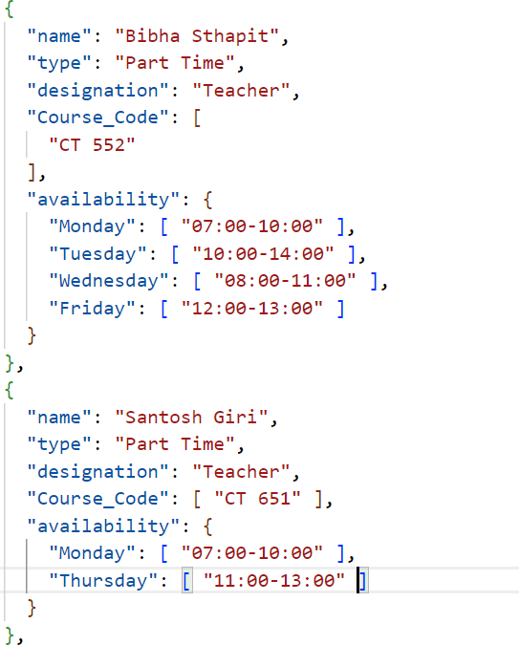
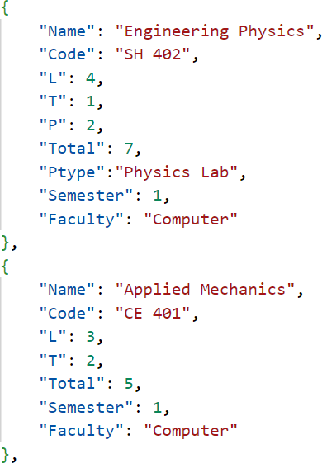
Figure 9.4: Subject Data
Figure 9.3: Teacher Data

Output
Here is the output that we have achieved successfully to date:

Home Page
This page serves as the main entry point for users, providing an overview of the website and easy navigation to other sections such as login, signup, and available routines.

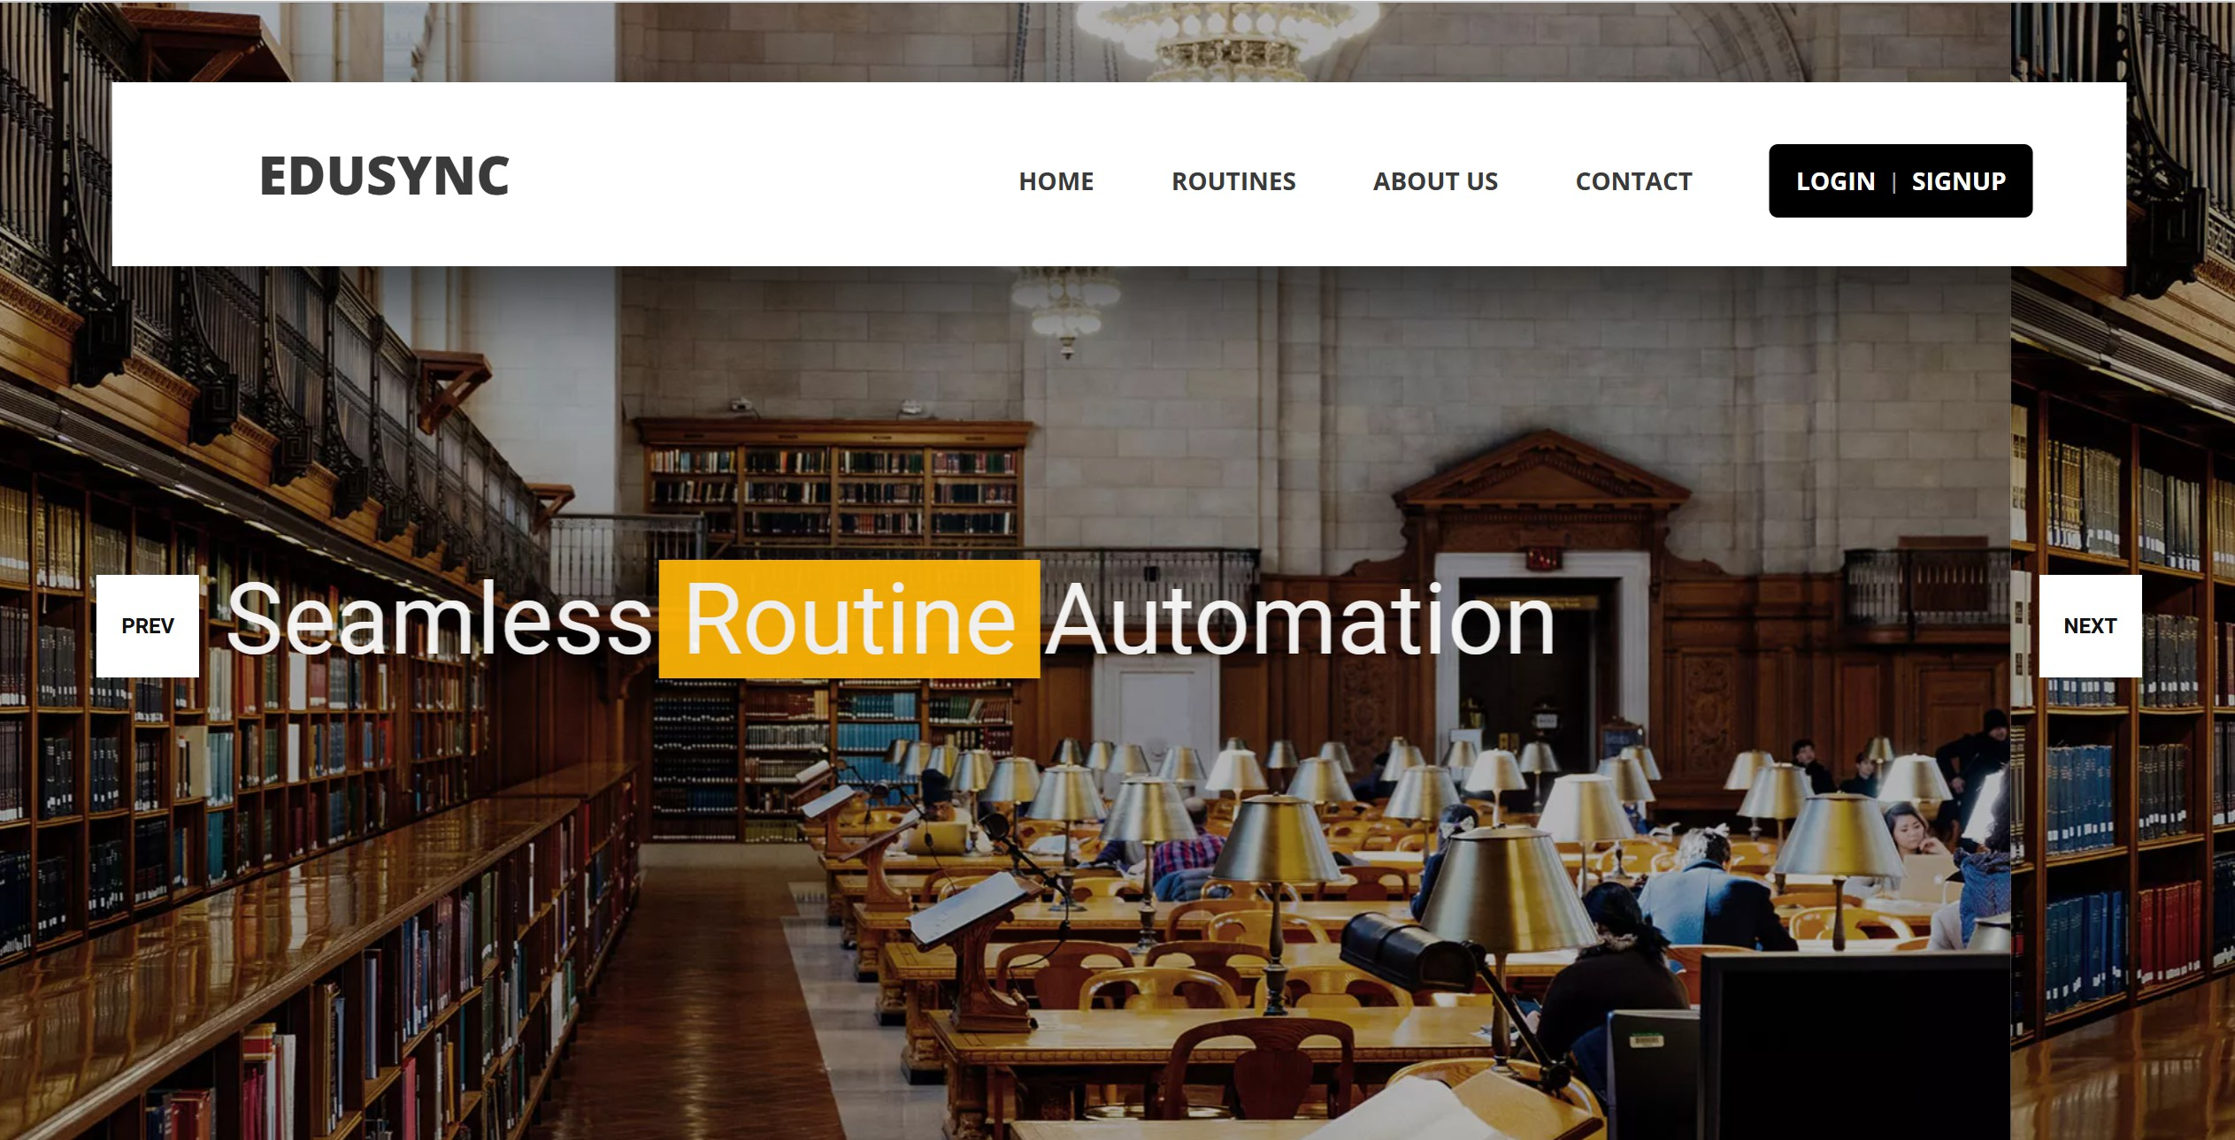

Figure 9.5: Home Page

Login
The login page allows users to securely input their email and password to gain access to their accounts, featuring options for password recovery and registration for new users.

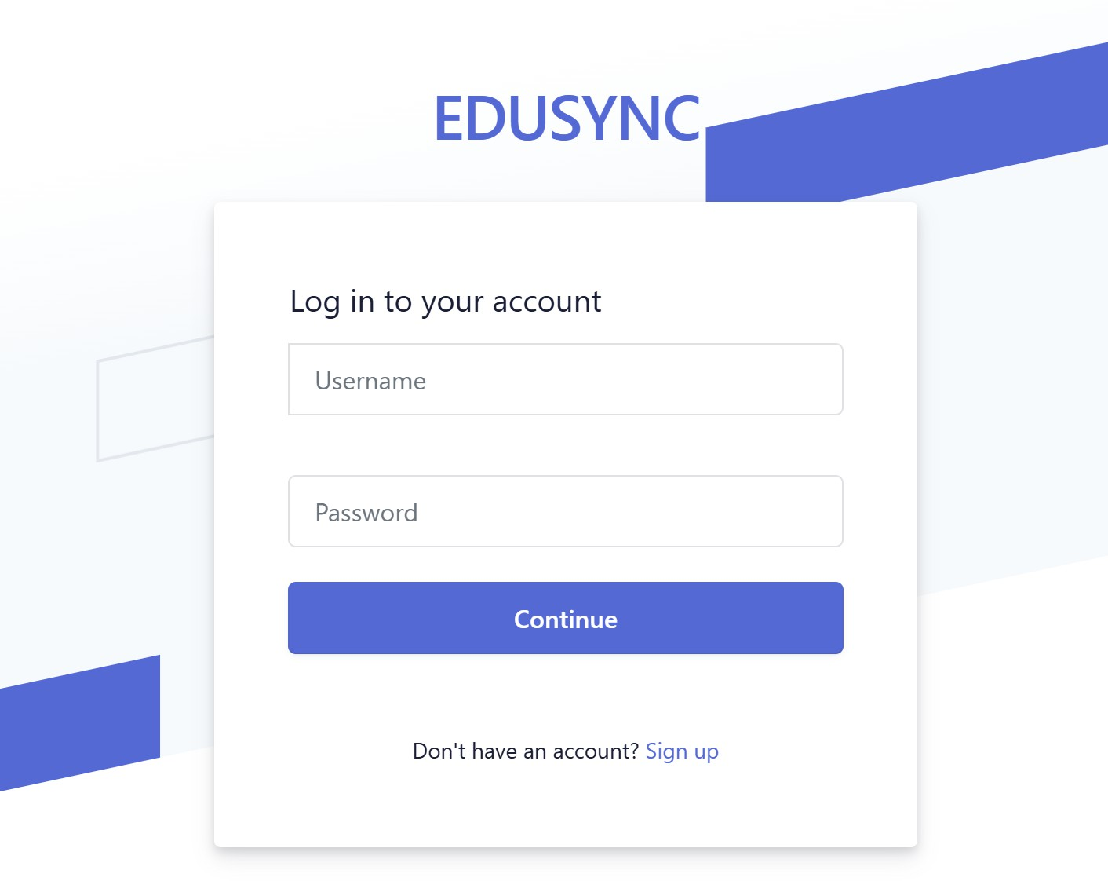

Figure 9.6: Login Page

Admin Dashboard
The admin dashboard provides administrators with an intuitive interface to manage users, blogs, and system settings, offering secure access and comprehensive functionality.
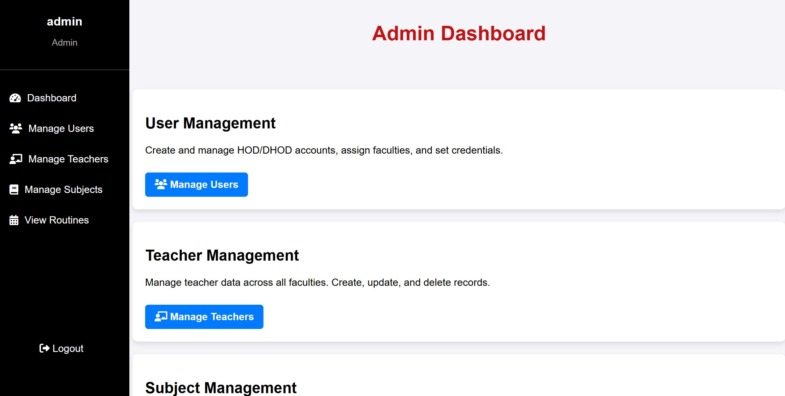

Figure 9.7: Admin Dashboard

User Management
The user management page enables administrators to add, update, or delete user pro- files, assign roles, and manage various user details efficiently.
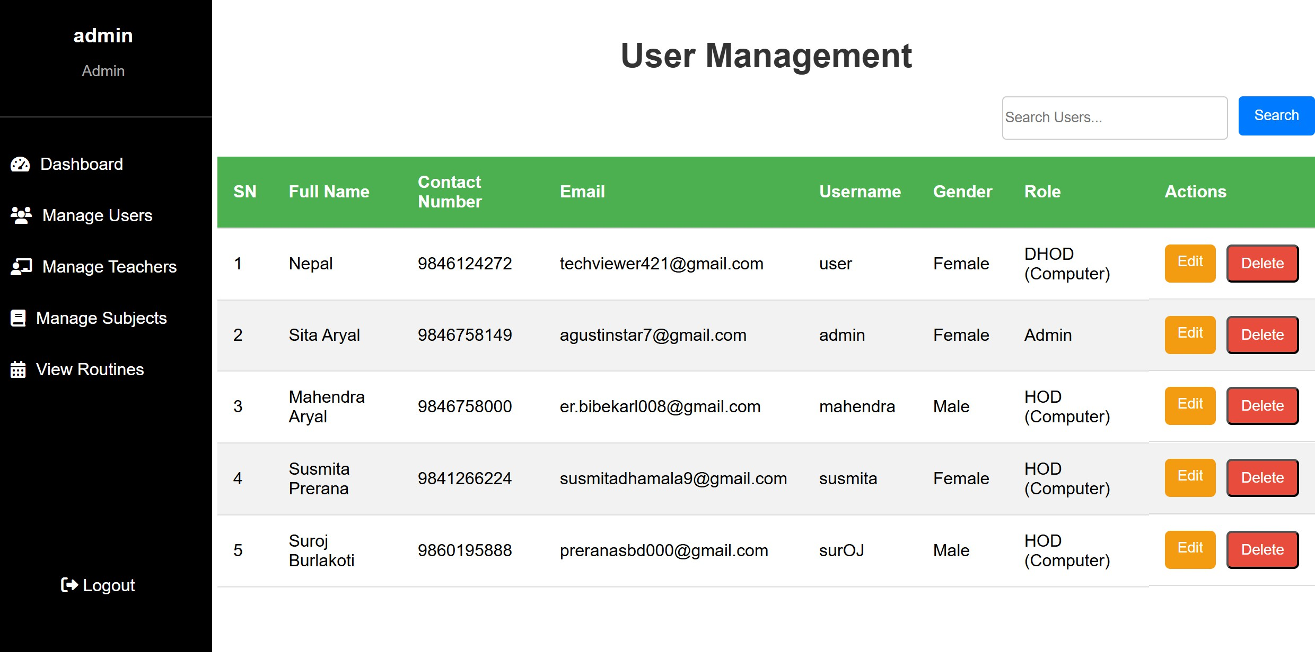

Figure 9.8: User Management Page

Teacher Management
The teacher management page gives administrators the ability to add, update, or remove teacher profiles, manage their availability, roles, and teaching preferences.

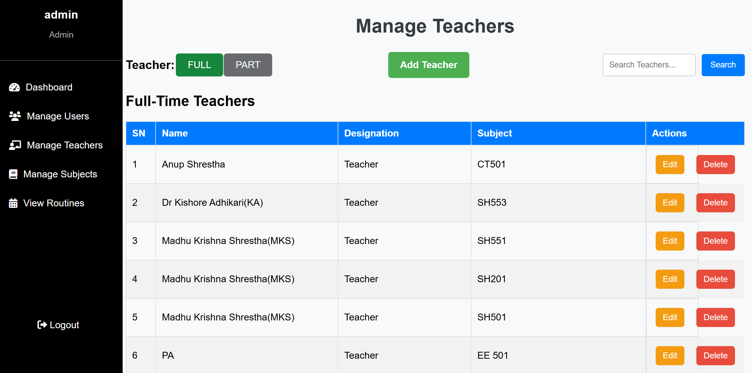

Figure 9.9: Teacher Management Page

Subject Management
The subject management page allows administrators to add, edit, or remove subjects, assign credit hours, and oversee all subject-related details effectively.
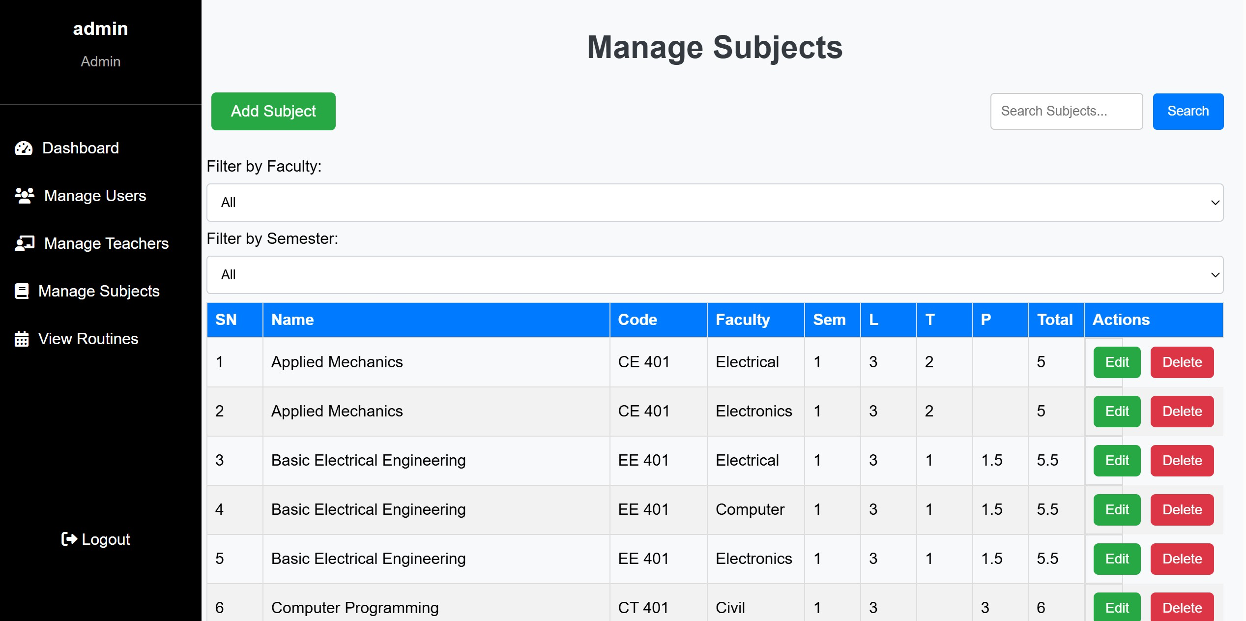

Figure 9.10: Subject Management Page

Teacher Edit Page
The teacher edit page allows administrators to modify existing teacher profiles, update their details, and adjust their roles, availability, and preferences for effective teaching management.

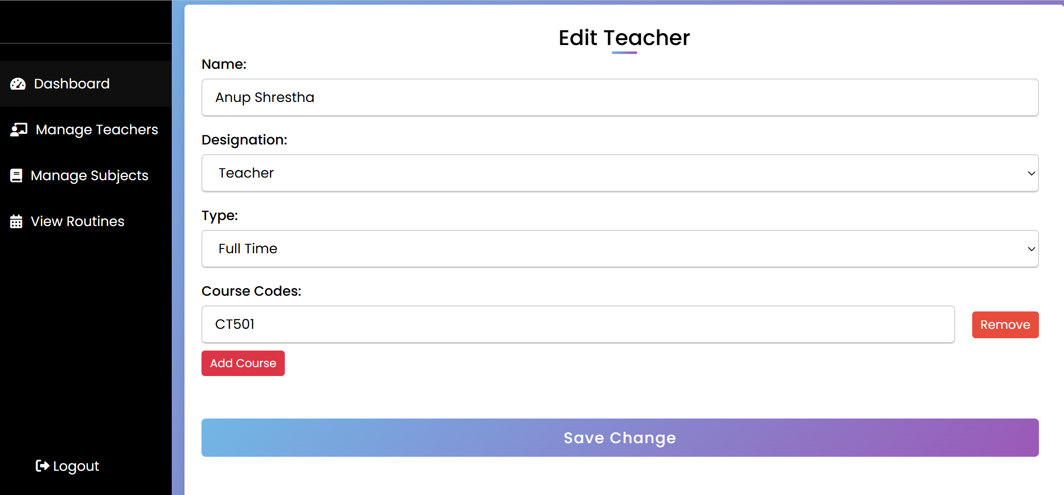

Figure 9.11: Teacher Edit Page

Sign Up Page
The sign-up page enables users to register with a structured form. It captures essential details, including Full Name, Email, Role, Contact Number, and Password. Users ver- ify emails via ”Send Verification Code” and ”Verify Code” buttons. The default role is ”Admin,” and a unique Username is required. Password confirmation and gender selection ensure security and customization.
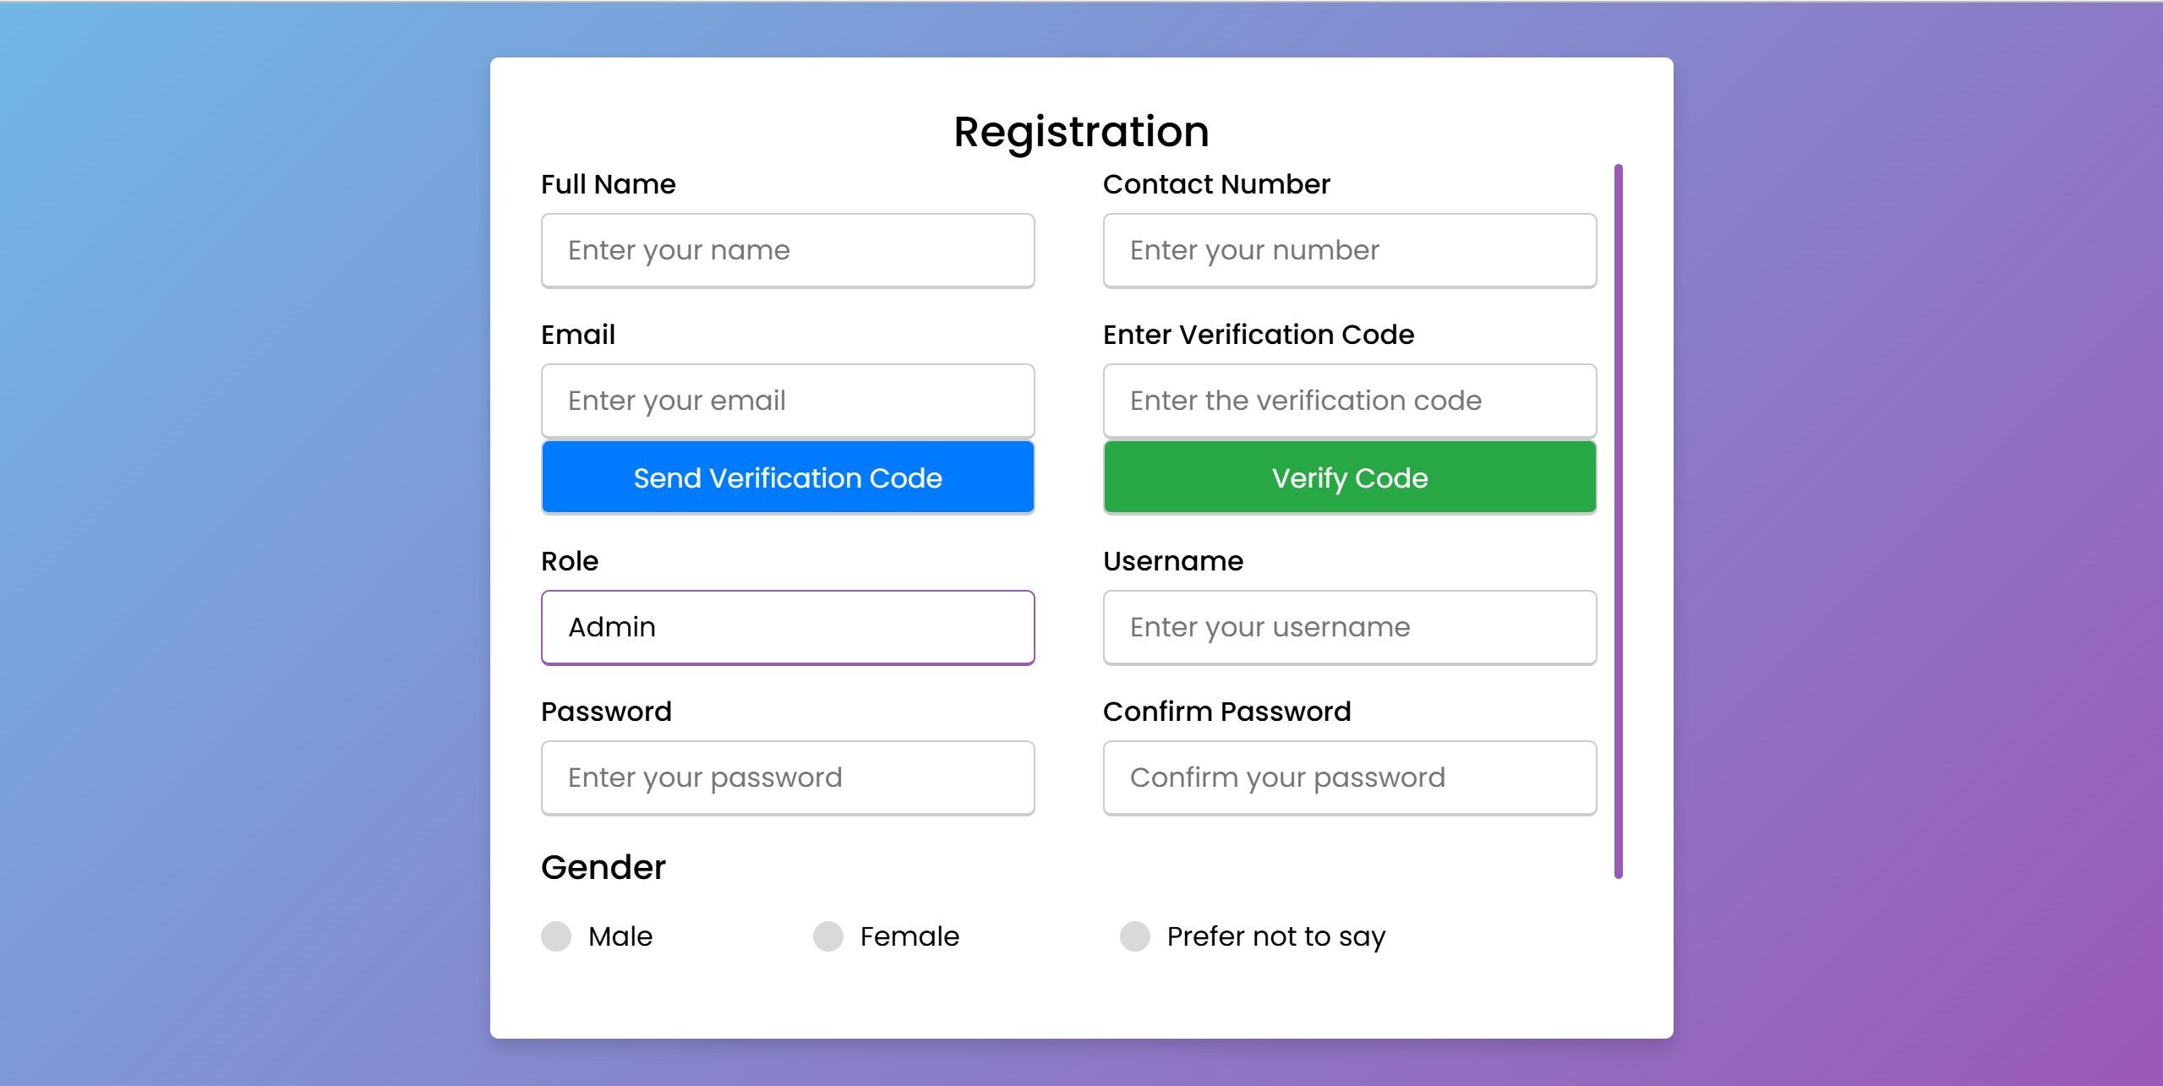

Figure 9.12: Sign up Page

Routine of Computer Department
This page displays the generated routine for the computer department, showing the allo- cated classes, times, and rooms for the courses in an organized and easy-to-read format. 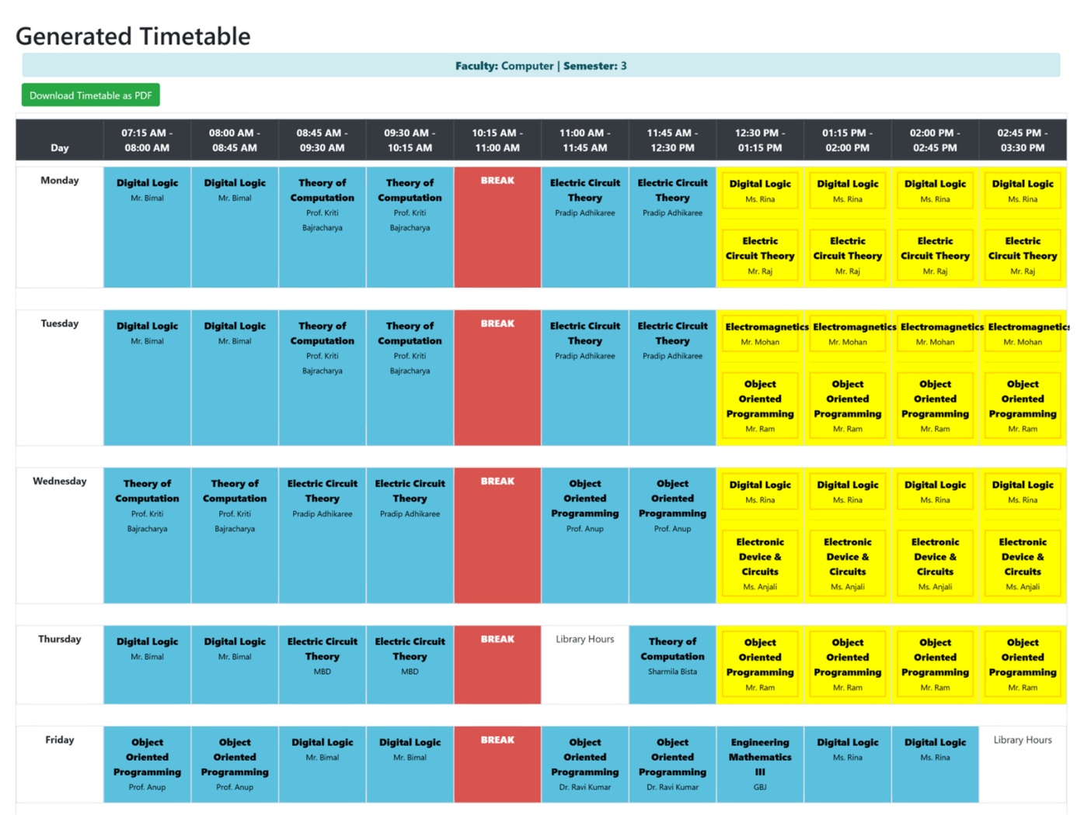
Figure 9.13: Generated Timetable
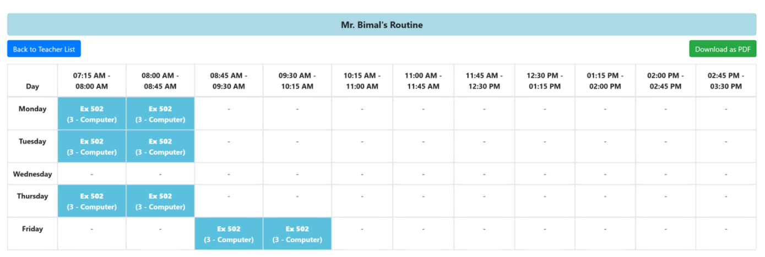
Figure 9.14.1: Individual Teacher Routine

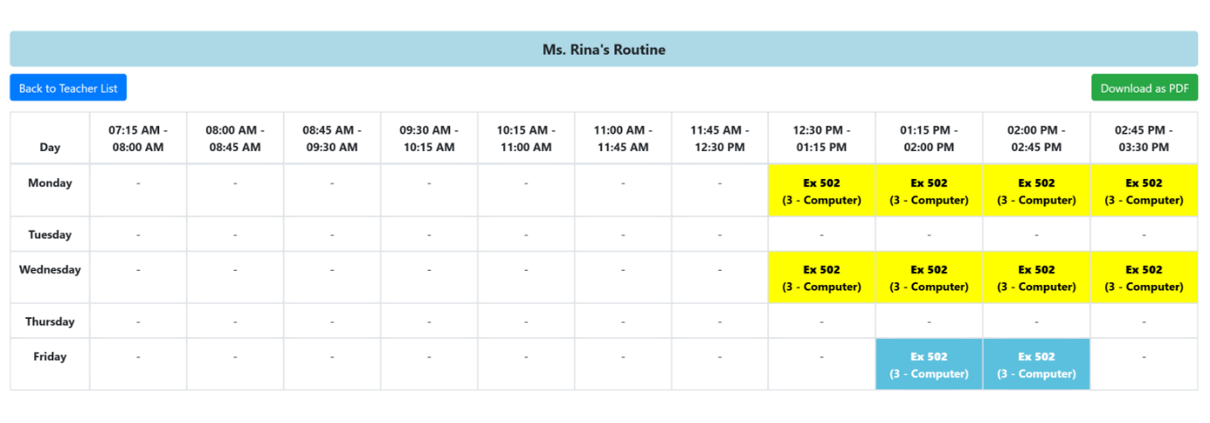
Figure 9.14.2: Individual Teacher Routine

System Training Data Flow Graph

A diagram representing how data is collected, processed, and utilized for timetable generation, ensuring continuous learning and improvements.
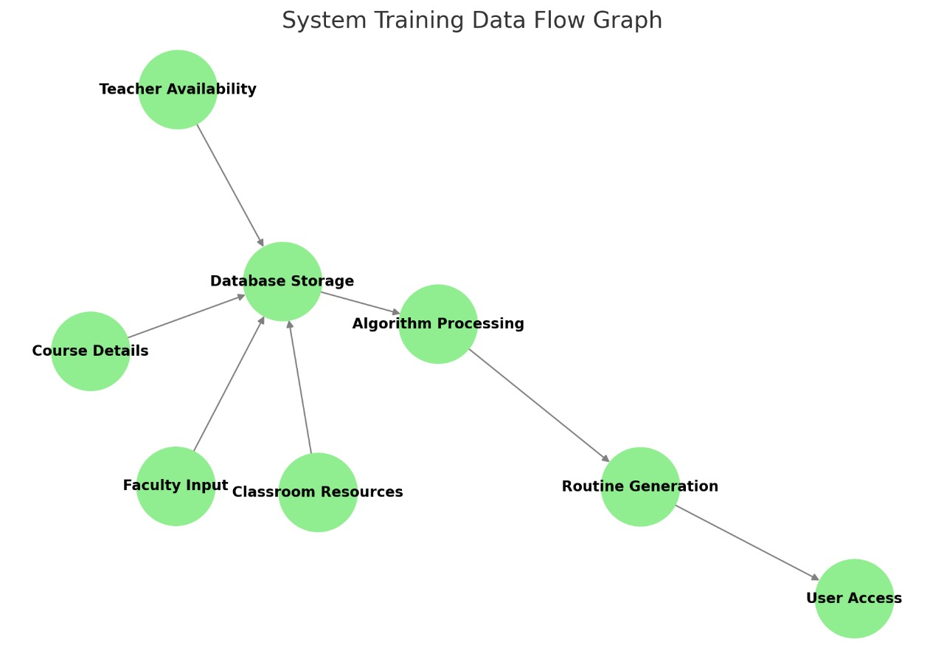
Figure 9.15: System Training Data Flow Graph

Constraints
The constraints that we treat are classified as hard or soft. Hard constraints are those to which a timetable has to adhere in order to be satisfied. A timetable is not viable if it does not satisfy them. Soft constraints are also those which should not been violated, but if this is not possible then the resulting timetable isn’t optimal.

Hard Constraints

- Teacher Workload Constraints

  - Maximum Workload Handling: A teacher cannot exceed their maximum workload. If no other teacher is available, the admin must manually adjust.

  - Non-Classroom Activities Exclusion: Non-classroom activities (such as supervision or meetings) are not considered in workload calculations.
  - Part-Time vs. Full-Time Availability: Part-time teachers can override full- time teachers for both theory and practical classes, but only if they are reg- ularly available.
  - Workload Formula: The formula to calculate workload is:

Workload = (Theory Classes × 1) + (Practical Classes × 3 × 0.8)

Project supervision and similar special cases are excluded from workload calculations.

Designation | Min Workload (period) | Max Workload (period)
CEO | 2 | 3
Principal | 2 | 3
Vice Principal | 11 | 14
HOD | 13 | 17
DHOD | 15 | 19
Full-Time Teacher | 19 | 25
Table 9.1: Workload distribution by designation

Subject Distribution Constraints

  - Theory Classes: Combine Lecture (L) and Tutorial (T) periods to count as theory classes, and allocate one extra credit hour to theory classes (not to practical classes).
  - Optional Tutorials: Tutorials are assigned lecture periods as theory classes.
  - Unallocatable Periods: If extra credit hours cannot be scheduled, prioritize the explicit Lecture (L) and Tutorial (T) periods for allocation.

Practical Class Allocation Constraints

Practical Periods Allocation:
    - For P = 1.5, assign one 3-period slot weekly.
    - For P = 3, assign two 3-period slots on different days.
  - Room Capacity: Practical lab room capacity must match the subject’s re- quirements for practical classes.
  - Multi-Batch Classes: Block practical slots once a batch’s session is as- signed to avoid overlaps.
  - Teacher Pairing: Pair one theory teacher with another eligible teacher for practical sessions, ensuring proper teacher coverage.

P type | Rooms Available
Hardware | 2
Software | 5
Field Visit | No room needed
English Lab | 1
Thermodynamics Lab | 1
Workshop | 1
Chemistry Lab | 1
Physics Lab | 1
Drawing | 2
Electrical Lab | 2
Table 9.2: Room availability for different practical types

Scheduling and Rescheduling Constraints
- Slot Blocking: High-credit-hour subjects should be blocked first.
- Conflict Resolution: Prioritize rescheduling for important subjects and high teacher workloads. High-credit-hour subjects should not be dis- placed.
- Cascading Conflicts: During conflicts, high-credit-hour subjects should take precedence.

Special Cases and Constraints
  - Unresolved Constraints: Any unresolved constraints must be flagged, notifying admins for manual intervention and suggesting reallocation strategies.
  - Frequent Violations: Recurring violations should be flagged for long- term resolution.
  - Vacant Slots: Attempts must be made to reallocate before leaving any slots vacant.
  - Practical Classes as Last Period: Practical classes should ideally be scheduled as the last period of the day. If conflicts arise, they should be rescheduled.

Teacher Designation-Specific Constraints
  - Workload Variability by Designation: Different teacher designations (e.g., HOD, Full-Time, Part-Time) have different workload limits.
  - Full-Time Teachers: Must teach two subjects from different semesters within the same semester type.
  - Part-Time Teachers: No workload cap applies. Their assignments are purely based on availability.

Error Handling Constraints
  - Unassigned Slots: Unassigned slots should be logged for manual re- view or automatically adjusted if possible.

  - Teacher Absence: If a teacher is absent, leave slots vacant and notify the admin for further action.
  - Practical Room Allocation: Practical lab assignments must be rotated to manage room shortages, ensuring no single lab room is over-utilized.

Practical Scheduling Constraints
  - No Overlapping Lab Sessions: Practical lab sessions of the same type must not overlap in the schedule.
  - Balanced Lab Room Utilization: Practical rooms must be utilized efficiently across the week, avoiding room shortages or overbookings.

Soft Constraints

- A classroom is not assigned to more than one teacher at the same time.
- A class should be divided into groups and each groups is assigned with lab class in different time slot.
- Lab class should be assigned after the theory class.
- Lab class of 25 mark should be assigned in alternate weeks.
- Lab class of 50 mark should be assigned in regular weeks.
- More priority should be give to the part time teacher.
- The subject should not be allocated to a time period inconvenient for a lecturer.

Outcome
The system offers advanced tools for managing teachers, subjects, and related information to ensure accurate routine generation across various departments. Through the Teacher Management Page, administrators can create or update teacher profiles, set availability, and define roles, while the Subject Management Page allows for managing subject details such as credit hours and categorization. This data is used to generate timetables for multiple departments, including Computer, Electronics, and Civil, as displayed in the respective routine pages, which present well-organized schedules for all relevant faculties. New users can easily register through the Sign Up Page, which features a secure email verification process to maintain data integrity and ensure only authorized users gain access. Additionally, the platform includes a User Management Page that enables administrators to manage user profiles by adding, editing, or deleting accounts, assigning roles, and overseeing system usage efficiently.

Future Enhancements
Up to this point, we have successfully developed and implemented the routine scheduling system for the Computer Department, but it is currently limited to only one semester. The same algorithm is designed to be scalable and will be applied to generate schedules for the remaining semesters in the future. However, one of the key limitations we are facing is the incomplete integration of practical lab constraints. As a result, the current implementation may not be able to handle all practical session requirements efficiently, which is an area that requires further refinement and improvement.

References
- Lim Ying Ying and Hazinah Kutty Mammi. Timetable scheduling system using genetic algorithm (tsuga). at IJIC (International Journal of Innovative Computing) Volume.
- Mayuri R Bagul, Sunil C Chaudhari, Sunita N Nagare, Pushkar R Patil, and KS Kumavat. A novel approach for automatic timetable genera- tion. International Journal of Computer Applications, 975:8887, 2015.
- Ratul Prosad, Md Ashikur Rahman Khan, and Ishtiaq Ahammad. De- sign of class routine and exam hall invigilation system based on ge- netic algorithm and greedy approach. Asian Journal of Research in Computer Science, 13(3):28–44, 2022.
- Mansi Savdekar, Chaitali Bornare, Kailas Birari, and Kanchan Kolhe. Timetable generation system.
- Maryam Alwashahi. Investigation and optimization of scheduling sys- tem in sohar university using genetic algorithm (ga). International Journal of Computer Applications, 126(11), 2015.
- S Alagu Lakshmi, Ms S SUJITHA, and N DURGA ME. Time table automation system using backtracking technique. International Jour- nal of Advanced Research in Biology Engineering Science and Tech- nology (IJARBEST) Vol, 2.
- Ashiqur Md Rahman, Sheik Shafaat Giasuddin, and Rashedur M Rah- man. Decision tree based routine generation (drg) algorithm: A data mining advancement to generate academic routine and exam-time tabling for open credit system. J. Comput., 5(1):12–22, 2010.
- Sneha N T Sweta Jadhav Tahura Sadaf Prof. Jyothi Patil, Shambhavi V. Automatic timetable generator. Ijraset Journal For Research in Ap- plied Science and Engineering Technology, 2023.

- Nikita Veer Vaishanavi Ugale Priyanka Agrawal Rutuja Kavade, So- hail Qureshi. Smart timetable system using ai and ml. International Journal of Creative Research Thoughts(IJCRT), 2023.
- asc timetables. https://www.asctimetables.com/. Accessed: 2024-06-
10.

